**Road Accident data analysis**

This article is about my first portfolio project "Road accident Dashboard" using Excel. This was guided project focuses solely on using one tool.

**Main Dashboard**

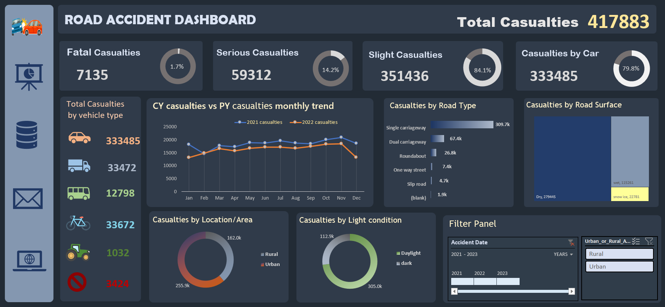

This article is about my first portfolio project "Road accident Dashboard" using Excel. This was guided project focuses solely on using one tool.

**Introduction**

Road accidents are a prevalent issue worldwide, leading to significant human and economic costs. The need to understand the underlying patterns and factors contributing to these accidents is effective and important.

    In this article I will take u through the execution and outcomes of my road accident dashboard project.

**Requirements and KPI's**

Road accident dashboard for year 2021 and 2022. we should create insights on the below requirements.

* Primary KPI -Total casualties taken place after the accident
* primary KPI's- Total casualties and Percentage of total with respect to accident severity and maximum casualties by type of vehicle

Secondary KPI's-

* Total Casualties with respect to vehicle type.
* monthly trend showing comparison of casualties for current year and previous year.
* Maximum casualties by Road Type.
* Distribution of total casualties by Road surface.
* Relation between casualties by area/Location and by Light condition.

**Data analysis sheet**

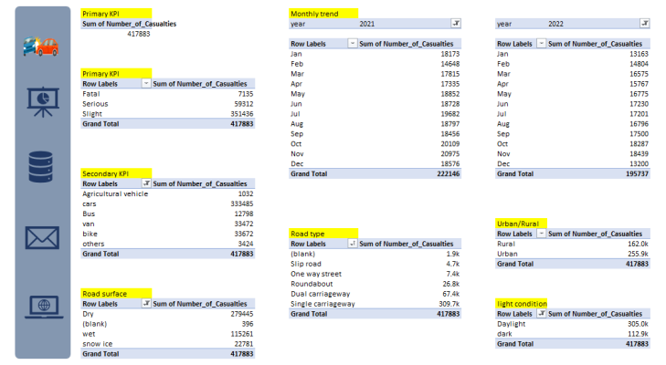

**Total Casualties Analysis (Primary KPI)**

This Dashboard reveals that total 4,17,883 Casualties occurred after accidents during the years 2021 and 2022. This information could be valuable for policy makers ,law enforcement and transportation agencies to implement targeted interventions aimed at reducing casualties and improving safety.

**Secondary KPI's**

* **Casualties by Accident severity**

The majority of Casualties (84.1%) are categorized as Slight severity, indicating the most Accidents result in minor injuries. However it is concerning that 14.2% of casualties are classified as serious severity. This highlighting the need for further investigation into the factors contributing to these.

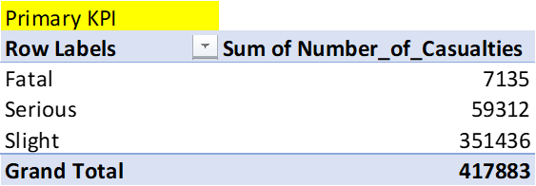

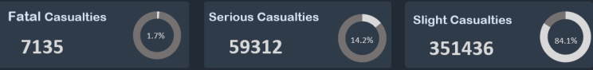

* **Casualties by Vehicle Type**

Car Accidents account for the highest number of casualties, contributing 79.8% of the Total. This suggests that efforts to improve Road safety should priorities interventions targeted at reducing car accidents.

Interventions aimed at reducing Road Accidents and Casualties:

1. Implementing stricter enforcement of traffic laws, especially for behaviour associated with car accidents.
2. Increasing public awareness campaigns on safe driving practices.
3. Improving infrastructure and road design to enhance safety for all road users.
4. Investing in technology solutions such as advanced driver assistance systems (ADAS) to help prevent accidents.

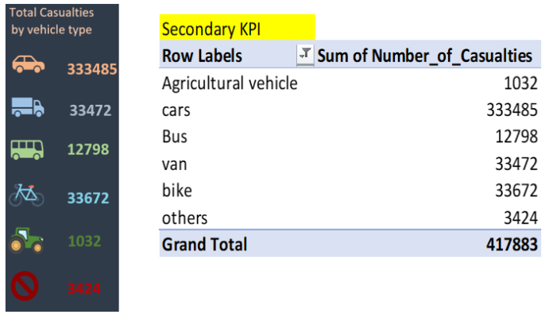

* **Monthly Trend analysis**

By comparing the total number of casualties for each month between the Year 2022 and 2021. This comparison will help identify any significant increases or decreases in casualties over time. The dashboard identifies critical periods and seasonal patterns.

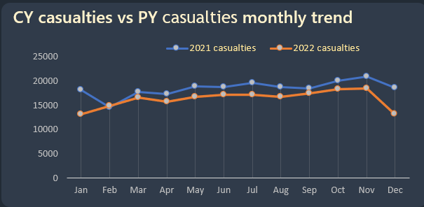

* **Road Type analysis**

Identifying the road types associated with the highest number of casualties is instrumental in developing effective Road safety strategies. These insights suggests that single carriageways are significantly more prone to accidents. possible reasons could include factors such as higher traffic volume, narrower lanes, lack of physical barriers and higher speeds.

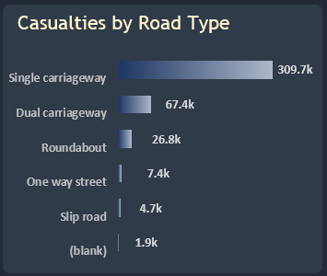

* **Casualties Distribution by Road surface**

The fact that dry road surfaces contribute to 67% of total casualties. Highlights the significance of road conditions in traffic safety.

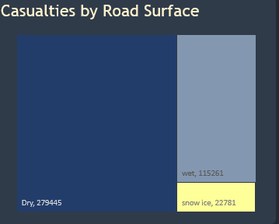

* **Casualties distribution relation Area/Location and Light Conditions.**

The comparison between casualties rural and urban reveals that urban areas have a higher number of casualties with 255.9k out of total casualties.

And the comparison between daylight and dark conditions in relation to casualties is crucial for road safety analysis. with daylight conditions accounting for a total of 305k casualties.

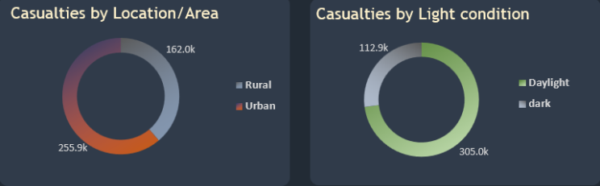

* **Other additional features of this Dashboard**

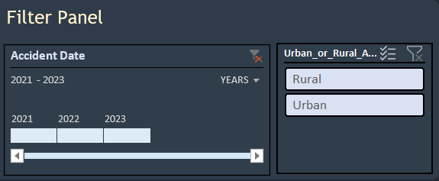

sticker navigations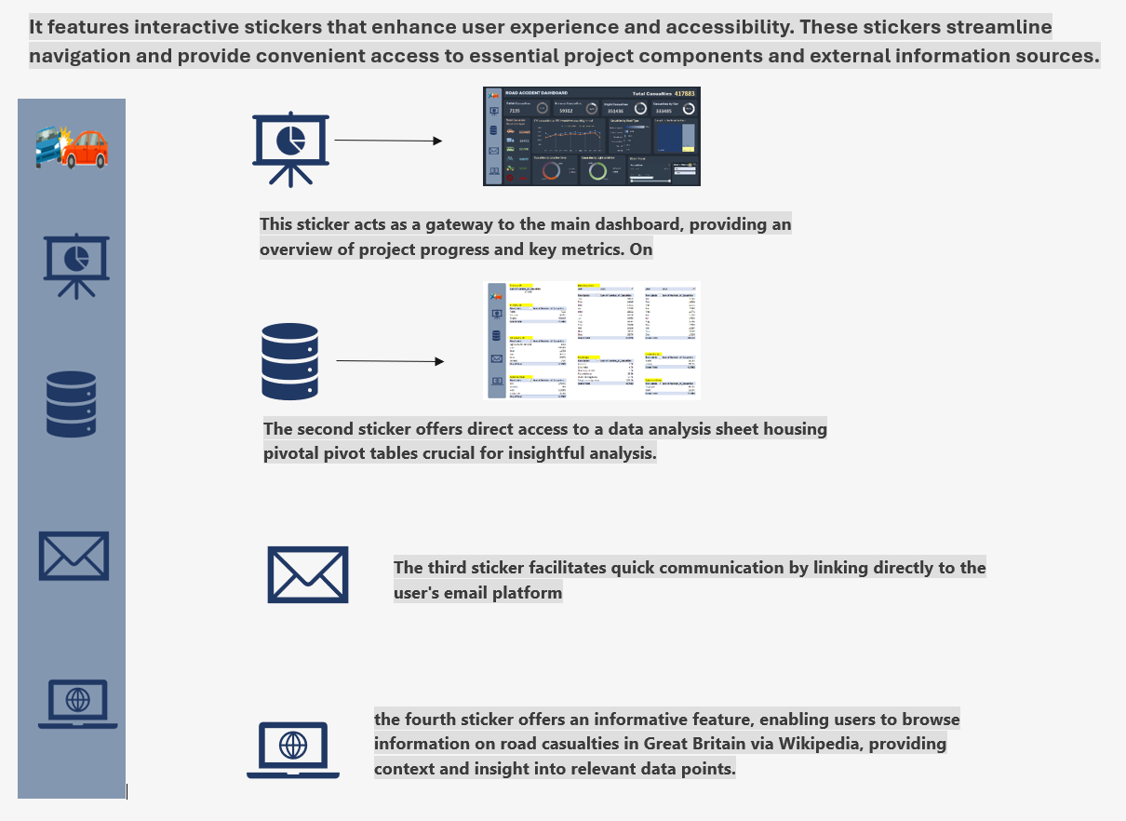

**Steps involved**

The steps involved here are Requirements gathering from client, identifying the stakeholders of the project, Data cleaning as per requirements, Data analysis by pivot tables and Excel functions, finally Data visualization to create charts and custom sheets to show the insights.

**conclusion**

Thank You for taking the time to read my article and learn about my project. in our road accident data analysis project using Excel has provided valuable insights into various factors contributing to casualties.

Kavya Raikar

kavyaraikar@gmail.com